Temperature and Humidity sensor

1. Components –
   1. ESP8266
   2. DHT11 temp and humidity sensor
2. Circuit diagram as shown below :

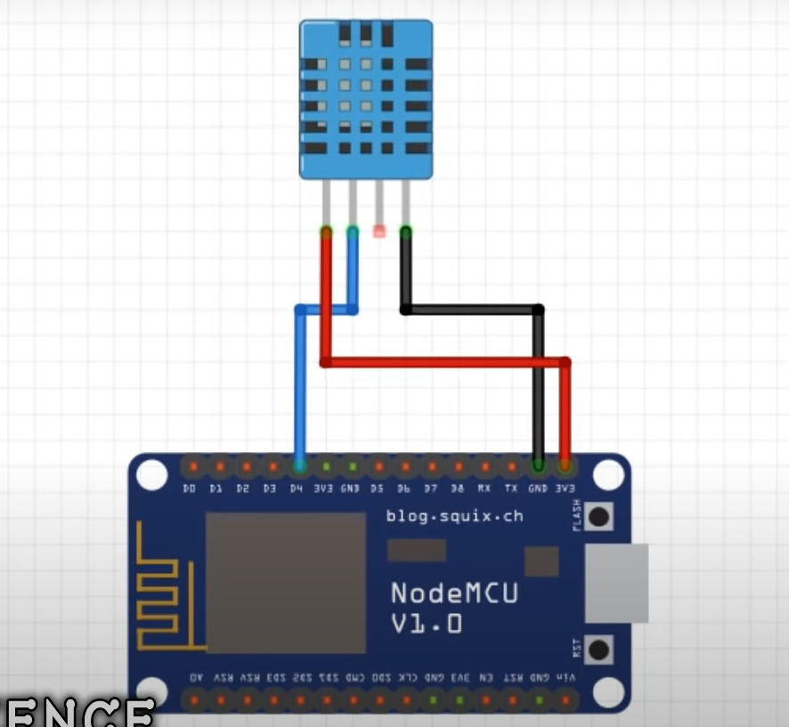

1. Code (Arduino IDE)
2. #define BLYNK_PRINT Serial    // Comment this out to disable prints and save space
3. #include <SPI.h>
4. #include <ESP8266WiFi.h>
5. #include <BlynkSimpleEsp8266.h>
6. #include <SimpleTimer.h>
7. #include <DHT.h>
8. // You should get Auth Token in the Blynk App.
9. // Go to the Project Settings (nut icon).
10. #define BLYNK_TEMPLATE_ID "TMPL3MItYuAMl"
11. #define BLYNK_TEMPLATE_NAME "Quickstart Template"
12. #define BLYNK_AUTH_TOKEN "37C-Go9VnnkcLjQdTEOFkXlVnpO0NO_x"
13. char auth[] = "37C-Go9VnnkcLjQdTEOFkXlVnpO0NO_x"; //Enter the Auth code which was send by Blink
14. // Your WiFi credentials.
15. // Set password to "" for open networks.
16. char ssid[] = "VAISHNAVI HOME 4G";  //Enter your WIFI Name
17. char pass[] = "rishikesh2611";  //Enter your WIFI Password
18. #define DHTPIN 2          // Digital pin 4
19. // Uncomment whatever type you're using!
20. #define DHTTYPE DHT11     // DHT 11
21. //#define DHTTYPE DHT22   // DHT 22, AM2302, AM2321
22. //#define DHTTYPE DHT21   // DHT 21, AM2301
23. DHT dht(DHTPIN, DHTTYPE);
24. SimpleTimer timer;
25. // This function sends Arduino's up time every second to Virtual Pin (5).
26. // In the app, Widget's reading frequency should be set to PUSH. This means
27. // that you define how often to send data to Blynk App.
28. void sendSensor()
29. {
30. float h = dht.readHumidity();
31. float t = dht.readTemperature(); // or dht.readTemperature(true) for Fahrenheit
32. if (isnan(h) || isnan(t)) {
33. Serial.println("Failed to read from DHT sensor!");
34. return;
35. }
36. // You can send any value at any time.
37. // Please don't send more that 10 values per second.
38. Blynk.virtualWrite(V5, h);  //V5 is for Humidity
39. Blynk.virtualWrite(V6, t);  //V6 is for Temperature
40. }
41. void setup()
42. {
43. Serial.begin(9600); // See the connection status in Serial Monitor
44. Blynk.begin(auth, ssid, pass);
45. dht.begin();
46. // Setup a function to be called every second
47. timer.setInterval(1000L, sendSensor);
48. }
49. void loop()
50. {
51. Blynk.run(); // Initiates Blynk
52. timer.run(); // Initiates SimpleTimer
53. }

4. Install dht.h, adafruit.h, simpletimer.h libraries from github

5. Add them from include libraries as zip option in Arduino IDE

7. login to blynk IOT

8. Create new project

9. Get two gauge widgets – temp and humidity

10. Set pin for temp as – Virtual pin 6 (V6)

11. Set pin for humidity as – Virtual pin 5 (V5)

12. Set the blynk token from this project, to the blynk token variable in the Arduino IDE code.

13. Add the wifi ssd and password in the code.

14. Download blynk app and on phone and login and then watch output there.

15. Make sure everything is connected to same wifi network.

16. Upload the code and see measurement changes.